Women’s, Gender, and Sexuality Studies: Gender, Sex and Power
Autumn 2014
Tu-Th 5:30-6:50pm
206 Denney Hall

Instructor: Tay Glover
Email: glover.167@osu.edu
Office: 30 Dulles Hall
Office Hours: Tuesdays before class 3:00pm-5:00pm and by appointment

Contact me by email. I will be sure to respond within 24 hours latest. Emails sent after 10pm may be responded to on the following day.

Email Etiquette: ALWAYS include WGSST 1110 in email subject line. Additionally, include a greeting, and signature.

ACCESS AND ACCOMODATIONS
We all learn and process information in different ways and I would like to make this course as accessible as possible. If there is something I can do to facilitate your learning in this class, please communicate this to me as soon as possible. I will do my best to address your needs. If you have documentation from the Office for Disability Services (614-292-3307; Pomerene Hall 150) for specific accommodations, please let me know immediately. With or without documentation, we can meet in person or communicate via email about how to improve your access to the course.
Course Description

This course is an introduction to the interdisciplinary scholarship in women’s, gender, and sexuality studies. The course will engage students in diverse and controversial cross-cultural feminist perspectives on social, economic, cultural, and political practices. The topics covered by this course relate to feminisms and women’s/social justice movements, gender socialization, racial formation, inequality and difference, labor and politics, the body, violence and sexualities, in which we will use scholarship, and political and social histories/events as context. We will explore the study of women, gender, and feminism by examining the intersections of race, class, sexuality, disability and gender across cultures and disciplines. We will also explore and interrogate the construction of identities and categories such as race, gender, sexuality, (dis)ability, class, and nation, and how these socially-constructed marked and unmarked categories reinforce each other, and are used to oppress and subordinate groups and individuals, mark bodies, and create structural and institutional inequalities, privileges, and hierarchies.

This course is a prerequisite for the major and minor in Women’s Studies. The course fulfills three GEC requirements: Cultures and Ideas, Social Science Individuals and Groups and Social Diversity in the United States.

Required Texts
Reading Women’s Lives. Pearson Custom Publishing (Autumn 2014 compiled by Tay Glover). Purchase at SBX Bookstore on North High Street.
Additional Texts: PDFs will be provided on Carmen for supplementary readings. There will also be blogs and videos assigned with links provided. Some course media will also be on the Course Secured Media page. Additional texts will be annotated as Carmen, video, or with links.
Course Learning Objectives
- To see sex, gender, sexuality, race, class, nationality, and ability as categories of analysis, a social construction, performative identities, a power relation, and a lens for rethinking ideas that seem to be “givens” and natural.
- To understand how identities are not fixed categories and at times intersect and contradict one another.
- To understand the ways in which women and people in all their diversity are affected by society, culture, and its institutions.
- To learn to use an intersectional lens for critique and analysis of social, cultural, political, economic and scientific assumptions/practices that produce and maintain relations of inequality.
- To understand the ways in which gender, race, sexuality, class, nationality, geographic location, and ability are interconnected and inform theories and methods of inquiry.
- To develop critical reading, writing, and thinking skills, as well as practice articulating your own supported ideas and arguments.
- To connect the lessons learned in the classroom to the world outside of academia.

Course Policies
*Disclaimer: Information on the syllabus should be accepted as accurate. The syllabus is subject to change by the instructor, in which change in dates, assignments, and policies will be revised in syllabus and stated on Carmen.

Plagiarism & Academic Integrity
Plagiarism is a serious offense. Plagiarism includes direct copying and paraphrasing from another author without acknowledging your source. OSU’s policy on plagiarism:

As defined by University Rule 3335-31-02, plagiarism is “the representation of another’s works or ideas as one’s own; it includes the unacknowledged word for word use and/or paraphrasing of another person’s work, and/or the inappropriate unacknowledged use of another person’s ideas.” Plagiarism is one of the most serious offenses that can be committed in an academic community; as such, it is the obligation of this department and its instructors to report all cases of suspected plagiarism to the Committee on Academic Misconduct. After the report is filed, a hearing takes place and if the student is found guilty, the possible punishment ranges from failing the class to suspension or expulsion from the university. Although the existence of the Internet makes it relatively easy to plagiarize, it also makes it even easier for instructors to find evidence of plagiarism. It is obvious to most teachers when a student turns in work that is not his or her own and plagiarism search engines make documenting the offense very simple.
There are ways to avoid plagiarism:
- Always cite your sources.
- Always ask questions before you turn in an assignment if you are uncertain about what constitutes plagiarism.
- See instructor if you are having difficulty with an assignment.
To preserve the integrity of OSU as an institution of higher learning, to maintain your own integrity, and to avoid jeopardizing your future, DO NOT PLAGIARIZE!

Writing Center
I am available to assist you with assignments and help you develop your work during my office hours or by appointment. The university also provides an incredible writing resource with the University Writing Center. The Writing Center allows you to make appointments to get assistance from trained writing tutors. To utilize this university-sponsored service, contact the Writing Center at (614) 688-4291 or http://cstw.osu.edu/students.

Class Dynamics Policies

Attendance: Prompt and regular attendance is necessary for your completion of this course. You are allowed one excused absence without penalty. Each additional absence will affect your attendance/participation grade. If you participate in athletics/university-sponsored involvement that will cause you to miss class, please let me know the first week of class. You must show proof of appointments, etc. for excused absences-this is university policy. Excessive tardiness and leaving class early will affect your attendance and participation grade. Students should not pack up until class is over.

Participation: You are expected to come to class on time, with the material assigned for that session read carefully and thoroughly. Readings should be completed by the date listed on the syllabus. Always bring your assigned reading and textbook to class. I expect you to have thought about what you’ve read, to have questions ready, and to have something to contribute to the class discussion of the material. Readings and assignments are intended to inform class discussion and course lectures; class discussions, and activities are all designed to supplement and contextualize the readings. Full attention should be given to classmates during presentations

Best Practices for Success: Take notes and summarize the readings in your own words, making note of any questions or unfamiliar terms for class discussion. Resist the urge to skim the readings, as this will not adequately prepare you for class. Be able to answer questions such as: What is the author’s main point/argument in the text? What are the authors' supporting arguments/points for their claim(s)? Setting? Context? Audience? Why might the piece be important?
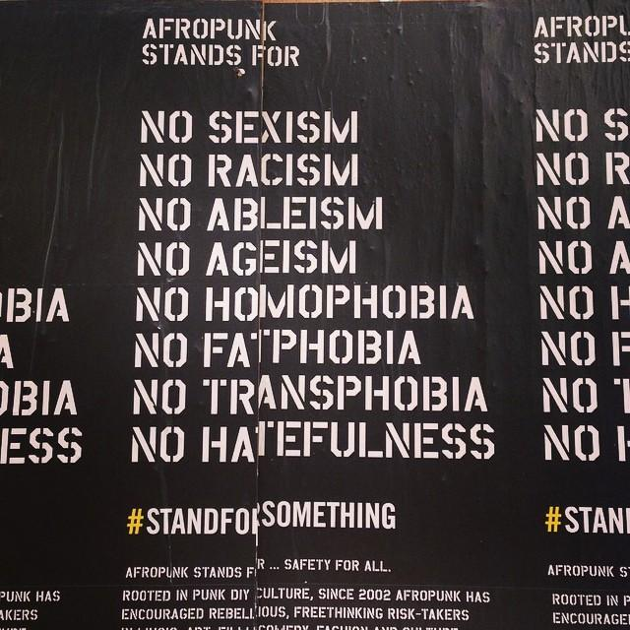

Content Disclaimer: Some of the issues we will discuss are controversial, about violence, and triggering; some people may be uncomfortable discussing some topics. If a topic is touchy, you may excuse yourself for a moment. This class addresses some of our most revered beliefs about culture, politics and power. Assume best intentions and respect the opinions of classmates. It is essential that we listen intently, respond respectfully and thoughtfully, and challenge each other to acknowledge the complexities of our diverse lived experiences.
Interruption will not be tolerated; nor will clear malicious statements of a racist, sexist, homophobic, ableist, transphobic, classist, xenophobic, victim-blaming nature.

Electronics Policy
Cellphones must be silenced and put away for the entire class period. Electronics such as laptops, Ipads, and note-taking devices are allowed for note-taking and class online readings access. If students are caught partaking in any other activity on permitted electronic devices- social networks, chatting, doing work for other classes, privileges will be dissolved for the semester. Participation points will be deducted as well. These rules are in place to guarantee utmost respect for the instructor and classmates’ learning.

Course Requirements

Attendance and Participation (115 points) 20%
- Attendance and in-class participation = 50 points
- Weekly Carmen posts = 65 points
Participation and attendance grade will be measured by your attending class and the extent to which you actively participate according to standards mentioned above. In-class participation points will be deducted for: sleeping, forbidden electronic use. Participation will also be assessed by weekly critical analysis Carmen posts. Carmen posts should respond thoughtfully and critically to discussion prompt, and include at least one question. Carmen posts will be in relation to the week’s readings, and will be due every Sunday at 9pm. Lack of participation will result in points being docked from your participation grade.
Grading
Attendance and Participation-20%
Writing Assignments-30%
Current Events Presentation-5%
Group Presentation-10%
Midterm Exam-15%
Final Exam-20%

Late/Makeup Work Policy: In-class assignments and activities that count for in-class participation points cannot be made up. Late assignments will not be accepted.

Writing Assignments- 30%
There will be 2 4-page essays assigned for this course that require students to critically engage in the course materials. You will be given paper prompts with instructions and a rubric for each paper. Papers should be submitted in hard copy at the beginning of class. Plan accordingly.
*Due Dates:
Paper #1- Thursday, October 2nd
Paper #2- Thursday, November 20th

* Paper format: 12 point Times New Roman font, double-spaced, one-inch margins, page numbers on top right, in-text citations and bibliography page in MLA format. Papers must fully meet page length requirement. Successful essays will have an introductory paragraph with a thesis statement, body paragraphs that are clearly related to each other and to the thesis statement, a concluding paragraph that reiterates the thesis statement and the evidence provided in the body paragraphs and comes to a point of conclusion. Points will be deducted from not meeting all of these requirements.

Group Presentation- 10%
You will be split into 6 groups of 5, and expected to present on one of the ‘Social Justice Today’ themes at the end of the semester. Each group will be expected to give a 15 minute presentation on the assigned topic with 10 minutes of discussion. The group is welcome to video, handouts, and power point presentation in their presentation. In addition to presenting to the class, each group member will be expected to turn in the evaluation about their topic, their group presentation, and the dynamics of the group work. Group presentation guidelines and evaluation sheets will be provided.

Current Events Presentation & Reflection: 5%
Each student will sign up for one day to bring in one “artifact” - a news story, a video clip, a commercial, a book, blog article – that connects to the topic and readings discussed in that day’s class. The student will be expected to give a 5-minute presentation and facilitate a 5-minute discussion on how course materials could be used to shed light on this particular topic. A 1-page reflection will be due analyzing the artifact and explaining how course materials for that day are relevant to it.

Midterm- 15% and Final Exams- 20%
There will be midterm and final in-class exams. Students will be given a study guide two weeks prior to each exam. There will also be in-class exam review sessions.

Extra Credit Policy:
Throughout the quarter, events will be announced as extra credit opportunities. Students must attend the event and submit a 2-page reflection paper within 1 week of the event that gives details of the event, and its’ connections to things in our course. Students may submit up to TWO extra-credit assignments, which can add an additional 2.5% to your cumulative essay grade, for a total of no more than 5%.
Grading Scale: A (100-95); A- (94-90); B+ (89-88); B (87-85); B- (84-80); C+ (79-78); C (77-75); C- (74-70); D (69-65); E= 64<
Course Schedule

Thursday, 8/28- Introduction to the Course

Week 1: What is Feminism?
Tuesday, 9/2- What is Feminism?
- “I’m Not a Feminist, But…” Popular Myths about Feminism. Penny Weis (Carmen)
- Womanist. Alice Walker (Carmen)
- Watch “We Should All Be Feminists: Chimamanda Adichie TED Talk” http://www.youtube.com/watch?v=hg3umXU_qWc

Thursday, 9/4- Understanding Ideology
- Excerpt from Actionable Postcolonial Theory in Education by Vanessa Andreotti (Carmen)
- Watch “Orientalism as a Tool of Colonialism” http://youtu.be/vdE18HdfanI?list=PLiHbJmHoOT2f0sVDtNDboatEjDzaxA5_P
- ***Key terms

Week 2: Constructions of Sex and Gender
Tuesday, 9/9- Gender/Sex Socialization and Performance
- Theme Introduction: Gender Socialization. Cynthia Burack
- “Not Your Mom’s Trans 101” by Asher http://tranarchism.com/2010/11/26/not-your-moms-trans-101/

Thursday, 9/11- Gender/Sex Socialization and Performance
- X: A Fabulous Child’s Story. Lois Gould
- “12 Things Every Gender Non Conforming Child Wants You to Know” http://raisingmyrainbow.com/2012/06/30/12-things-every-gender-nonconforming-child-wants-you-to-know/
*In-class Writing Workshop

Week 3: Interrogating Race and Nation
Tuesday, 9/16- Race and Ethnicity
- Asian is not Oriental. Anonymous
- Race Under the Microscope: Biological Misunderstandings of Race- https://www.youtube.com/watch?v=-1re0x3dgbY&feature=youtu.be

Thursday, 9/18- Colonial, Imperial Legacies
- The Homeland, Aztlan. Gloria Anzaldua
- “The Ugly History of Racist Profiling in America” http://www.vox.com/michael-brown-shooting-ferguson-mo/2014/8/19/6031759/ferguson-history-riots-police-brutality-civil-rights/in/5757650

Week 4: Interrogating Race and Nation
Tuesday, 9/23- Colonial, Imperial Legacies for Women of Color
- Reflections on the Black Woman’s Role in the Community of Slaves. Angela Davis (Carmen)
- The Filipina’s Breast: Savagery, Docility, and the Erotics of the American Empire. Nerissa S. Balce (Carmen)

Feminisms and Women’s Movements
Thursday, 9/25 (Divide and conquer)
- Declaration of Sentiments and Resolutions (1848). The Seneca Falls Women’s Rights Convention of 1848
- Is Equality Indigenous? The Untold Iroquois Influence on Early Radical Feminists. Sally Roesch Wagner
- Class and Race in the Early Women’s Rights Movement. Angela Davis (Carmen)
- “The Myth of Shared Female Experience and How it Perpetuates Inequality” Mia McKenzie. Black Girl Dangerous Blog http://www.blackgirldangerous.org/2013/05/28/2013513the-myth-of-shared-female-experience/

Week 5: Feminisms and Women’s Movements
Tuesday, 9/30- Politicizing Identity (Divide and conquer)
- A Black Feminist Statement. Combahee River Collective (Carmen)
- Redstockings Manifesto. Redstockings
- La Consciencia de la Mestiza: Towards a New Consciousness. Gloria Anzaldua
- A Day Without Feminism and Third Wave Manifesta. Jennifer Baumgardner & Amy Richards

Thursday, 10/2- Oppression and Privilege
- Oppression. Marilyn Frye
- White Privilege: Unpacking the Invisible Backpack. Peggy McIntosh
- “12 Things white people can do now” http://qz.com/250701/12-things-white-people-can-do-now-because-ferguson/
*Paper #1 due *Receive Midterm Study Guides

Week 6: Theorizing Oppression, Privilege, Hierarchy and Social –Isms
Tuesday, 10/7- Oppression and Privilege
- Owning My Advantage, Uncovering my Collusion Judith H. Katz
- Homophobia: A Weapon of Sexism. Suzanne Pharr

Thursday, 10/9- Social-isms, Difference, and Resistance
- Race, Class, and Sex: Women Redefining Difference. Audre Lorde
- The Other Body. Ynestra King http://acceleratedmotion.wesleyan.edu/primary_sources/texts/bodiesandmachines/other_body.pdf

Week 7: Midterm Week
Tuesday, 10/14- Review for Midterm Exam
*Midterm Evaluations
Thursday, 10/16: MIDTERM EXAM

Week 8: Sexuality
Tuesday, 10/21- Shame and Resistance: Reimagining Sexual Politics and Desire
- “What is Slut Shaming?” -Finally, A Feminist 101 Blog
http://finallyfeminism101.wordpress.com/2010/04/04/what-is-slut-shaming/
- Selection from The Cult of Virginity. Jessica Valenti (Carmen)

Thursday, 10/23- Rethinking Sexual Normativity, Sexual Politics and Desire
- (Sex)Abled: Disability Uncensored- http://youtu.be/qA020ShNQr8
- Watch BEYONCE’ The Visual Album (Secured Media)
- Uses of the Erotic: The Erotic as Power. Audre Lorde (Carmen)

Week 9: Motherhood & Reproductive Rights
Tuesday, 10/28- Motherhood
- Theme Introduction: Motherhood and Reproduction. Sally Kitch
- Excerpts from Motherhood in Bondage. Margaret Sanger
In class: To My Unborn Son: On Mike Brown, Police Brutality and the Fears of Black Motherhood- http://www.forharriet.com/2014/08/to-my-unborn-son-on-michael-brown.html?m=1

Thursday, 10/30- Reproductive Rights
- From Norplant to the Contraceptive Vaccine: The New Frontier of Population Control. Dorothy Roberts
- “Tear Gas Is an Abortifacient. Why Won’t the Anti-Abortion Movement Oppose It?”- http://m.thenation.com/blog/181318-tear-gas-abortifacient-why-wont-anti-abortion-movement-oppose-it
- Bodily Integrity and Forced Medical Treatment: The Case of Angela Carder. Cynthia R. Daniels (optional)

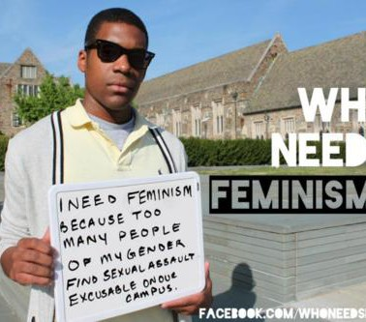
Week 10: The Body and Representation
Tuesday- 11/4- The Body (Divide and Conquer)
- The Body-Power and Politics. Valerie Lee
- The Beauty Myth. Naomi Wolf
- When I Was Growing Up. Nellie Wong (Carmen)
- Watch Miss Representation
Thursday, 11/6- The Power of Representation
- Watch Dreamworlds and complete Study Guide; bring to class.

Week 11: Violence
Tuesday, 11/11- Thursday, 11/13 NO CLASS
Complete readings on rape culture and view lecture online. Must still complete weekly Carmen post.
- The Not-Rape Epidemic. Latoya Peterson
- Raped: A Male Survivor Breaks His Silence

Week 12:
Tuesday, 11/18- Masculinity
- Confessions of a Recovering Misogynist. Kevin Powell
- Men Changing Men. Robert Allen and Paul Kivel
- Watch Tough Guise (Secured Media)
In class case study of Ferguson: http://www.huffingtonpost.com/2014/08/14/media-black-victims_n_5673291.html?utm_hp_ref=email_share
http://www.empowermagazine.com/iftheygunnedmedown-teaches-great-lesson-black-stereotypes/

Thursday, 11/20- Work and Class
- Work, Poverty and Economic Policy. Mary M. Fonow
- The Feminization of Immigration. The National Council for Research on Women
- For Immigrant Maids, Not a Job but Servitude. Doreen Carvagal
*Paper #2 due

Week 13: No Class- Thanksgiving Holiday

Week 14: Social Justice Today: Theory in Practice
Tuesday, 12/2 Presentations:

Prison Abolition, Policing
- The Caging of America. Adam Gopnik (Carmen)
- Chapters 1 & 2 of Are Prisons Obsolete? By Angela Davis (Carmen)

Immigration
- The Impact of Unintended Consequences of the 1996 US Immigration Reform Act on Women. Maria Gomes and Fariyal Ross-Sheriff (Carmen)
- Debunking the Myth of Immigrant Criminality: Imprisonment Among First-and Second-Generation Young Men. Ruben G. Rumbaut, et al. (Carmen)

Xenophobia, Terrorism, Militarization
- Gender, Culture and Religion: An Islamic Perspective. Amina Wadud
- “Terrorism and Privilege: Understanding the Power of Whiteness.” Tim Wise http://www.timwise.org/2013/04/terrorism-and-privilege-understanding-the-power-of-whiteness/
- “A Former Marine Explains All the Weapon of War Being Used by Police in Ferguson” http://m.thenation.com/article/181315-catalog-ferguson-police-weaponry

Thursday, 12/4 Presentations:

Globalization and Global Economies
- Watch “The Story of Stuff” http://storyofstuff.org/movies/story-of-stuff/

Queer and Trans Politics
- 7 LGBT Issues That Matter More Than Marriage. http://www.buzzfeed.com/hfetter/7-lgbt-issues-that-matter-more-than-marriage-fk74
- Marriage Will Never Set Us Free. Dean Spade and Craig Willse (Carmen)
- Free Cece Trailer

The State of Education
- “Thousands of black and Latino kids lost their schools in 2013”. Trymaine Lee http://www.msnbc.com/melissa-harris-perry/what-happens-when-kids-lose-their-schools
- THE DIRTY DOZEN: HOW CHARTER SCHOOLS INFLUENCE STUDENT ENROLLMENT Kevin G. Welner. http://www.otlcampaign.org/sites/default/files/resources/nepc-dirty-dozen-charter-enrollment.pdf
- UCLA Students Make a Spoken Word Video http://www.huffingtonpost.com/2013/11/08/ucla-black-enrollment-freshmen_n_4242213.html

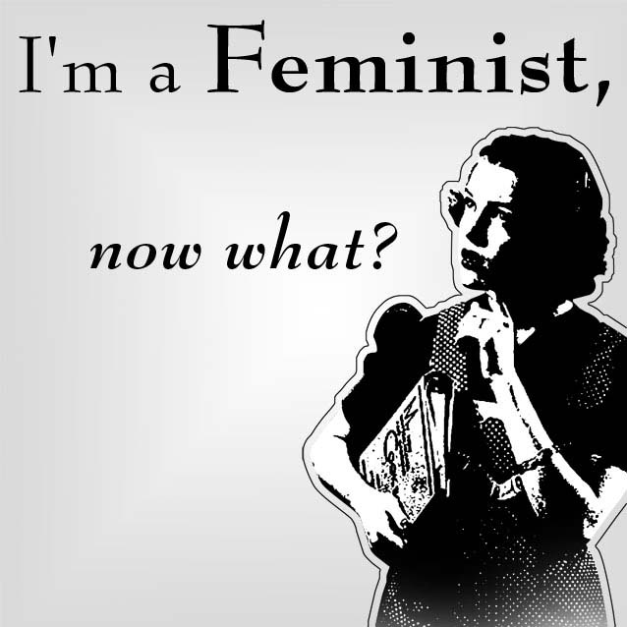
Last Day of Class, 12/9
No assigned reading. Final Review

***Final Exam will be held Tuesday, Dec. 16th 8:00pm- 9:45am

